**Name: Session:**

**Programming II**

**Lab Exercise 2/21/2022**

1. Create an application that calculates a car’s gas mileage. The formula for calculating the miles that a car can travel per gallon of gas is:

$$MPG=\frac{miles}{gallons}$$

The application should have TextBox controls that let the user enter the number of gallons the tank requires to fill up and the number of miles driven since the last fill up. When the Calculate MPG button is clicked, the application should display the MPG. The application should also have a Clear button that clears the input boxes as well as the result. The application should also have an Exit button that exits the application.

Use the following to test your application:

|  |  |  |
| --- | --- | --- |
| **Gallons** | **Miles** | **Miles/Gallon** |
| 10 | 375 | 37.50 |
| 12 | 289 | 24.08 |
| 15 | 190 | 12.67 |

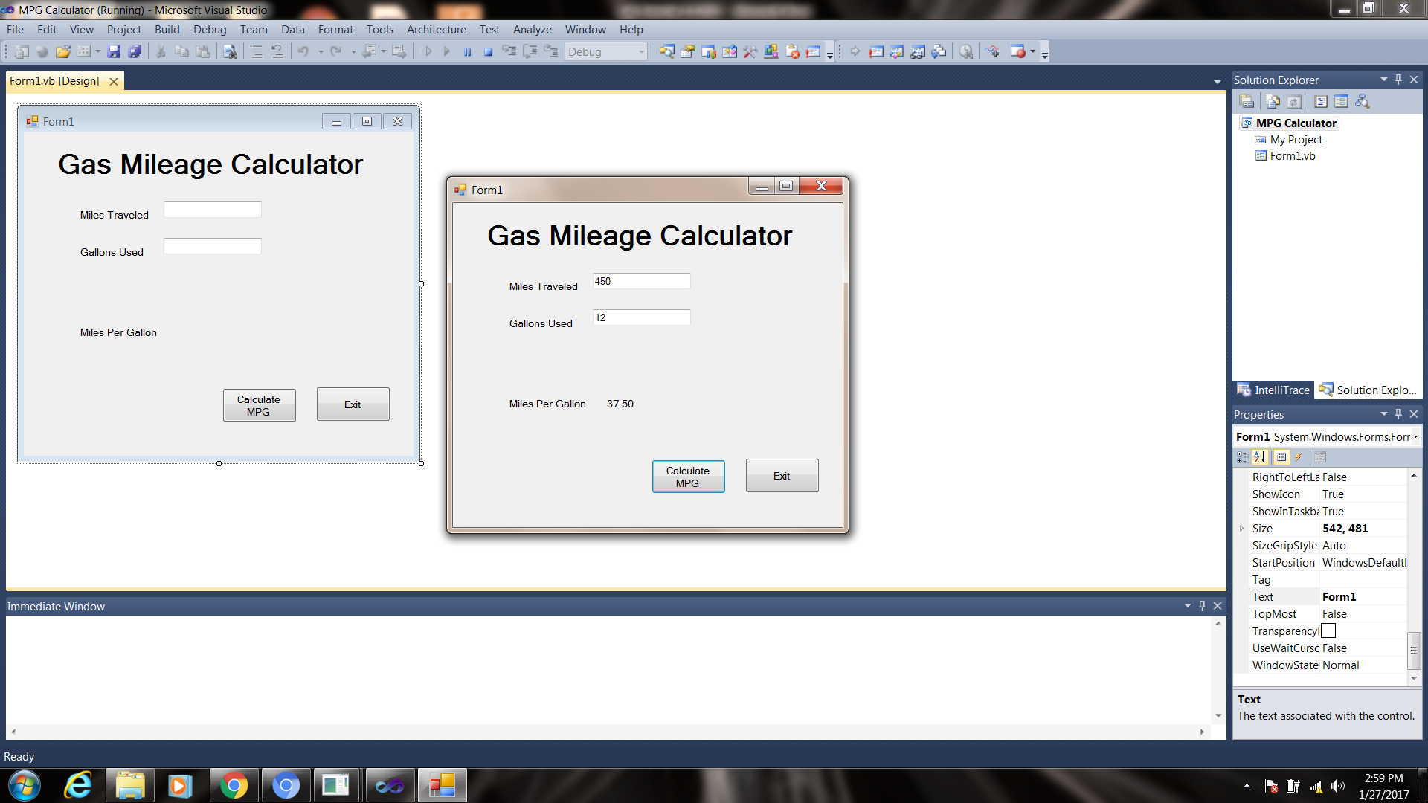

1. There are three seating categories at a football stadium. Class A seats cost $15 each, class B seats cost $12 each, and class C seats cost $9 each. Your application should report the revenue generated for each class as well as the total revenue when the Calculate Revenue button is clicked. Your application should have a Clear button that clears the input boxes as well as the result. The application should also have an Exit button that exits the application.

Use the following to test your application:

|  |  |  |
| --- | --- | --- |
| **Class** | **Ticket Sales** | **Revenue** |
| A | 320 | $4,800.00 |
| B | 570 | $6,840.00 |
| C | 890 | $8,010.00 |
| Total |  | $19,650.00 |

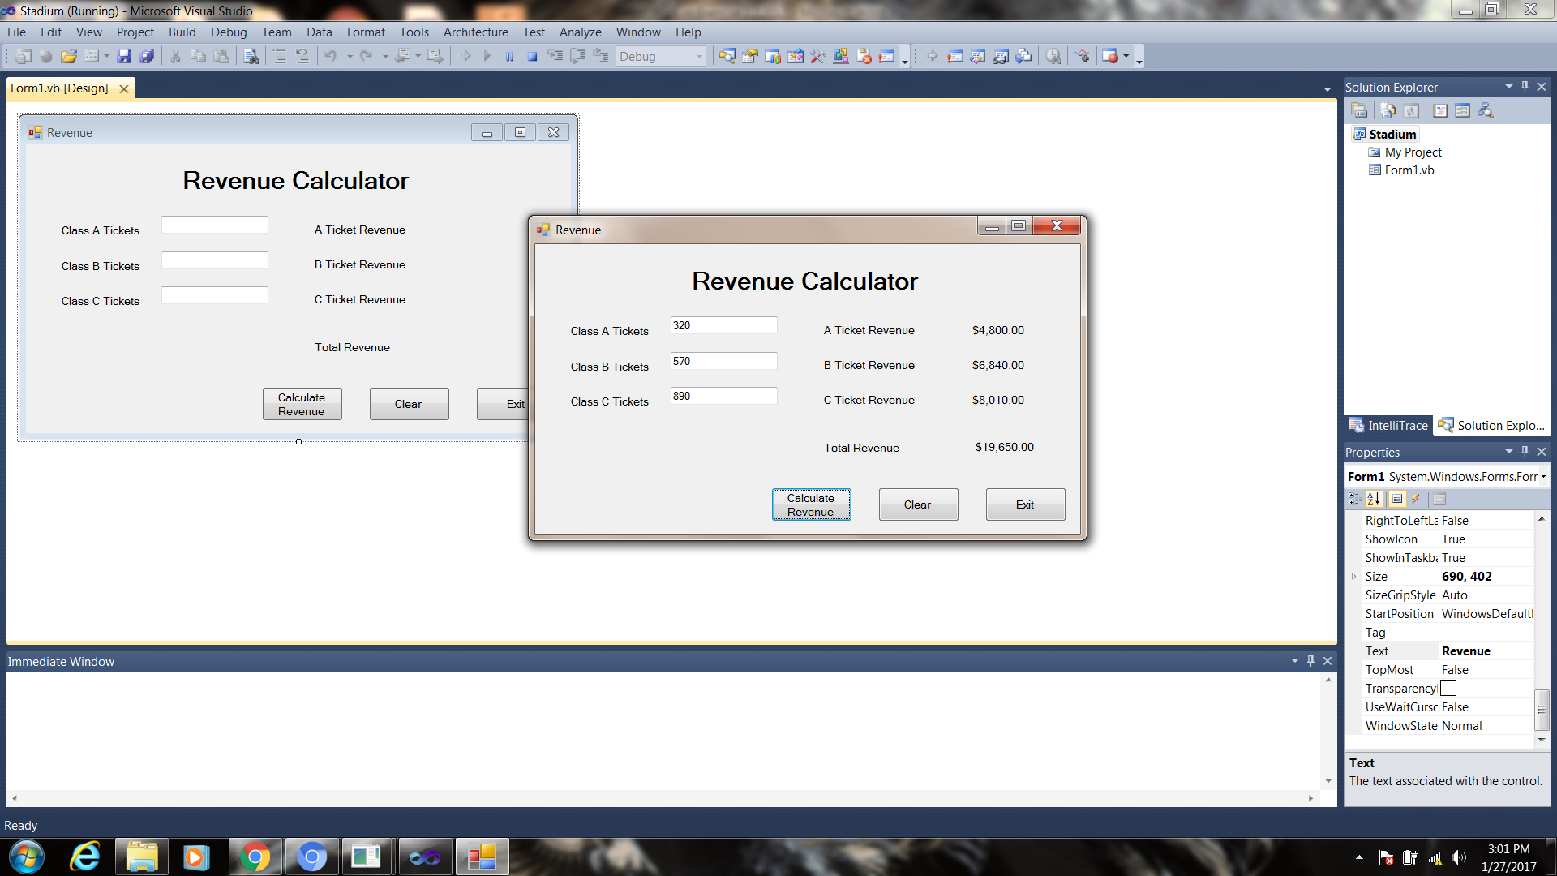

1. Create an application that allows the user to enter 5 test scores. The application should calculate the average of the test scores when the Calculate Average button is clicked. Your application should have a Clear button that clears the input boxes as well as the result. The application should also have an Exit button that exits the application.

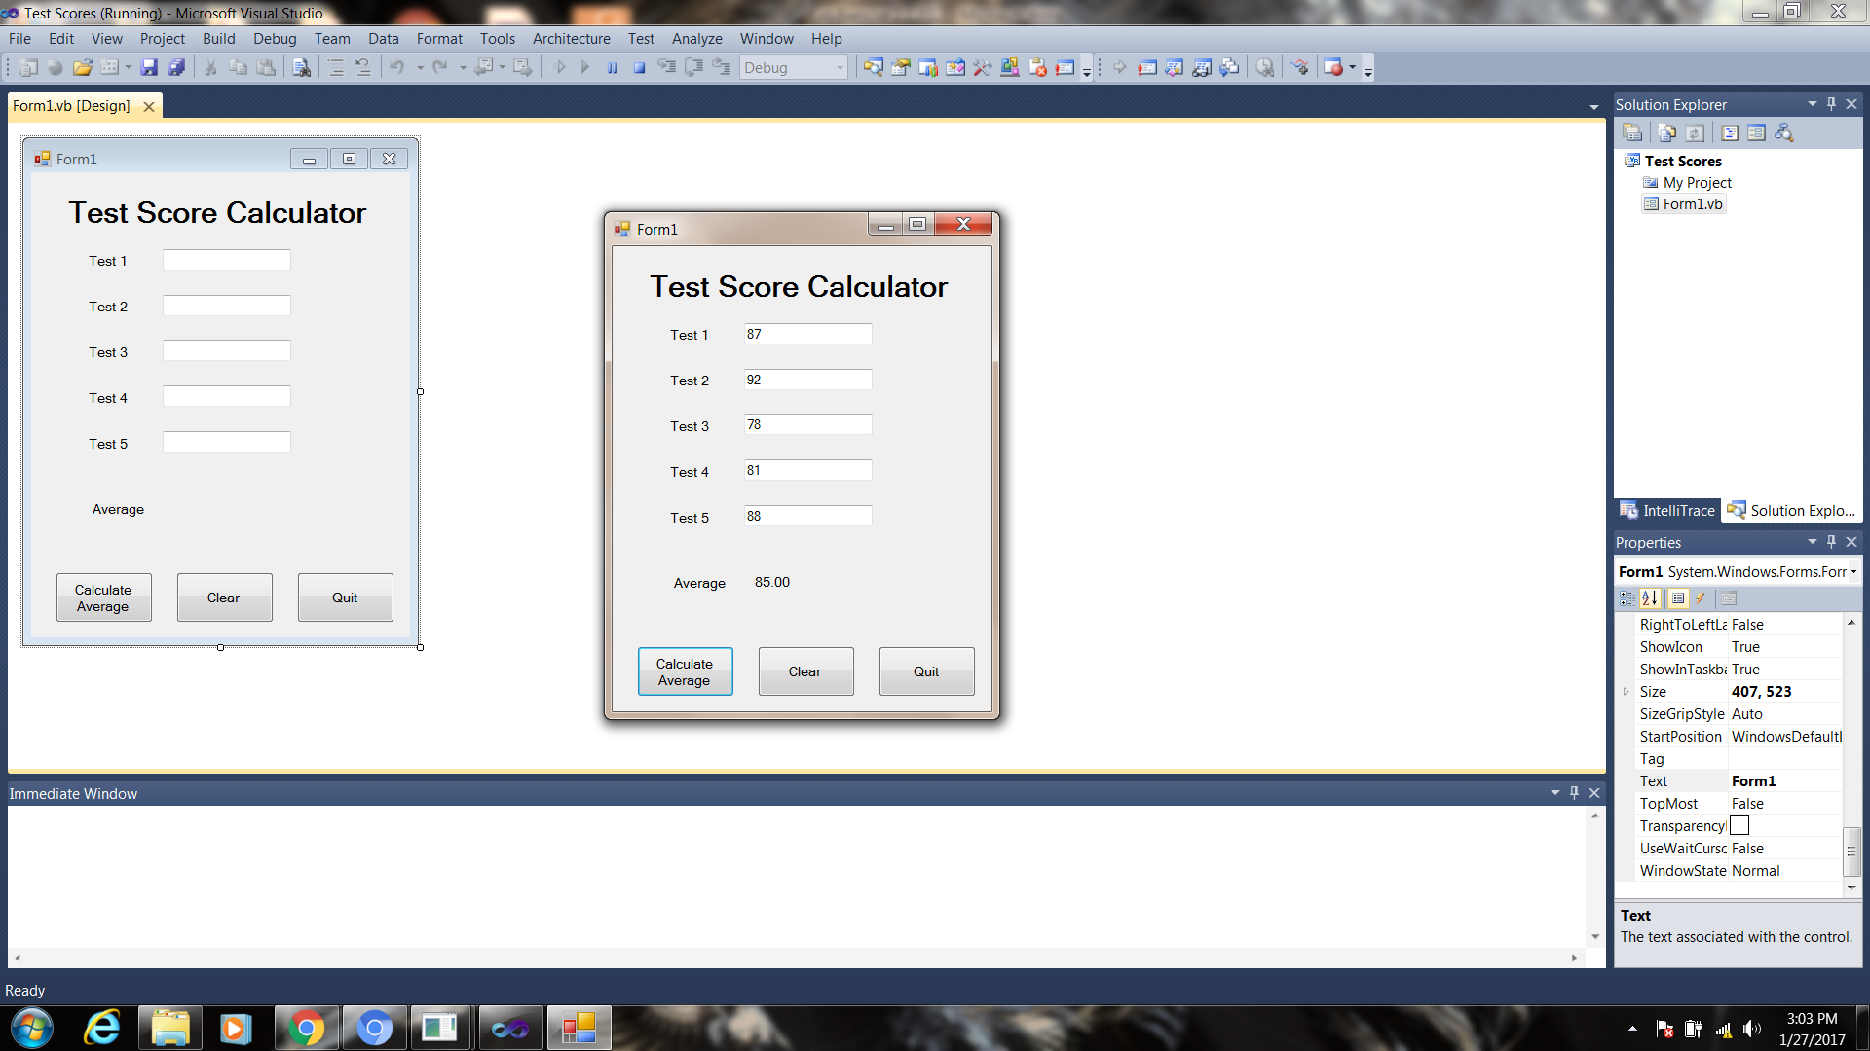

**When you have completed these three applications, submit your source code and a screen shot of your running application.**